Why do you define a printinfobox command in the template (left) and then you do not use it in the actual sheet (right)?
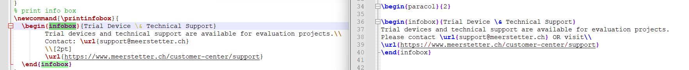

I think it’s a good idea to define it in the class as it will be the same across all datasheets. But duplicated information like this will lead to deviations. Please use either one or the other.

